Instructions to authors for the preparation of the final paper
(max 12 pages)
The paper’s title is typed 16 pt, bold, the initial capitalized only, and centered at the top of the page.

Your name (s)
Your affiliation, address,
postal code, City, Country
Phone: +xx xxx xxxx xxx, Fax: +xx xxx xxxx xxx, your_email@xxx.org
The name of the author(s) is typed 12 pt bold centered in upper and lower case letters. Affiliation(s) and complete address(es) are typed 12 pt centered in upper and lower case letters.

===Explanation of template starts from here. ===
This is a template of the full paper for the 7th Mission Idea Contest.

Please submit your manuscript as a WORD file (.docx) through the MIC application website where you submitted the abstract (http://www.spacemic.net/application6.html), and send a PDF file by email to MIC office (info@spacemic.net). (If you have difficulty uploading it to the website, you can send the Word file by email too.) Note that only submissions in the English language will be accepted.

The paper should not exceed 12 pages in total length and strictly adhere to the following outline and formatting guidelines.

Please feel free to contact Contest Secretariat for any questions at info@spacemic.net.

==Explanation ends. Please delete unnecessary parts when you write. ==

Abstract: A one-paragraph abstract of not more than 300 words must be included at the beginning of the paper. It should be a summary (not an introduction) and complete in itself. The abstract should indicate the subject dealt with in the paper and state your mission idea’s overview. Readers should not have to read the whole paper to understand the abstract.

1. INTRODUCTION

In this section, describe the fundamental need (humanitarian, business, scientific, etc.) your mission idea addresses. Also, acknowledge existing literature on the topic.

1.1 Paper Title

The paper’s title is typed 16 pt, bold, the initial capitalized only, and centered at the top of the page. The name of the author(s) is typed 12 pt bold centered in upper and lower-case letters. Affiliation(s) and complete address(es) are typed 12 pt centered in upper and lower-case letters.

1.2 Headings

Headings of the sections are typed 12 pt in capital letters, placed flush left. Subheadings and sub-subheadings are typed 12 pt in bold upper and lower-case letters placed flush left.

1.3 Footnotes

Footnotes should appear only, if it is necessary. Footnotes are typed 10 pt.

1.4 Illustrations and Captions

Keep in mind, please, that all figures and graphs will be reproduced exactly as you submit them. Therefore, make sure to provide them in an adequate quality. Place captions, numbered in their respective order, beneath the figures and above the tables, as shown in Table 1 and Fig. 1.
Table 1 Font sizes for papers
Font Size | Appearance (in Time New Roman or similar looking fonts)
 | Regular | Bold | Italic
16 |  | title
12 | author email, address and affiliation | Author name(s)  Headings (in capital letters),  Subheadings and  Sub-subheadings (in upper and lower case letters)
11 | cell in a table | table caption,  figure caption
10 | reference item  abstract body | abstract heading | reference item (partial)

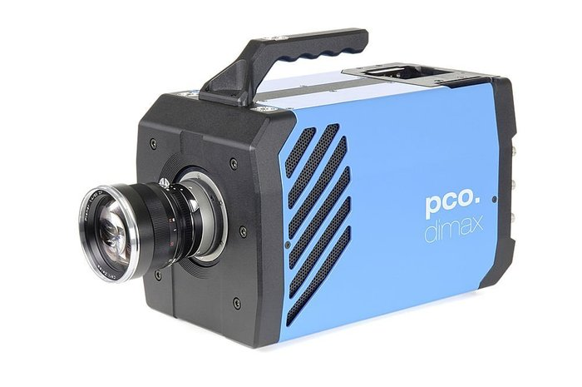
Fig. 1 Example of an unacceptable low-resolution image

1.5 Symbols and Abbreviations

Use only standard symbols in text and illustrations. Unusual units and abbreviations should be defined the first time they are used.

1.6 Equations

The numbers identifying equations should be placed in parentheses on the right. Please, make sure that no ambiguities arise as follow

(1)

1.7 Sections

The manuscript should be divided into sections, subsections and sub-subsections with clearly marked subtitles (in accordance to instructions in section 1.2 above) and numbered numerically (e.g. 2.1.3). Type the main body of the text single-spaced, beginning flush left. Leave one blank line between paragraphs and between paragraphs and headings/sub-headings.

1.8 Fonts

If possible, the font Times New Roman, 12 pt, or similar looking fonts should be used.

1.9 Page Numbers

Do not apply page numbering.

2. MISSION OBJECTIVES

Describe the target planet and/or asteroid to be observed and why you want to go there (scientific objectives). Include scientific reasons why the proposed mission has a significant impact on gaining new knowledge or solving social problems.

3. CONCEPT OF OPERATIONS INCLUDING ORBITAL DESIGN EXPERIMENTAL CONCEPT AND SETUP

Describe the mission scenario (from launch to realization of the final objectives, etc.) and describe the orbital design to realize the mission. Use diagrams, figures and/or tables if required. Formation flight of multiple explorers is also allowed if the mass restriction (relationship between total mass and V-infinity) is not violated.

4. KEY PERFORMANCE PARAMETERS

List and explain the required key technologies with several essential performance parameters (accuracy, bit rate of data transmission, etc.) which are essential to realizing your mission. If the technologies are not realized yet, you should indicate how to realize them and their possibility of R&D success. For example, required technologies include high precision orbit change, deep-space communication, observation sensors, power in deep space, and/or autonomy.

5. SPACE SEGMENT DESCRIPTION

Describe the conceptual design for your satellite system or systems. List key specifications (e.g., mass, volume, peak and average power, link budget, attitude control accuracy, delta-V for mid-course maneuver, etc.). Diagrams or simple CAD drawings are encouraged.

6. SPECIAL ASPECTS OF THE MISSION

If you have some originality of analyzing and/or designing this mission, please describe it. Also, you can make a detailed discussion here.

7. CONCLUSION

Summarize and conclude your mission proposal.

8. REFERENCES

References to published literature should be quoted in the text in brackets and grouped at the end of the paper in numerical order, typed 10 pt, and presented as follows:

[1] J. K. Knowles and E. Reissner, Note on stress-strain relations for thin, elastic shells. J. Math. Phys. 37, 269-282 (1958)
[2] H. S. Carslaw and J. C. Jaeger, Operational Methods in Applied Mathematics, 2nd edition. p.121. Oxford University Press, London (1953)
[3] Authors’ Guidelines. Available online at: www.dlr.de/iaa.symp (accessed August 2015)

