Instructions to authors for the preparation of final paper (max 12 pages)
The title of the paper is typed 16 pt, bold, the initial capitalized only and centered at the top of the page.

Your Name(s)
Your affiliation, address,
postal code, City, Country
Phone: +xx xxx xxxx xxx, Fax: +xx xxx xxxx xxx, your_email@xxx.org
The name of the author(s) is typed 12 pt bold centered in upper and lower case letters. Affiliation(s) and complete address(es) are typed 12 pt centered in upper and lower case letters.

===Explanation of template starts from here. ===
This is a template of full paper for the 6th Mission Idea Contest.

Please submit your manuscript as a WORD file (.docx) through MIC application website where you submitted the abstract (http://www.spacemic.net/application6.html), and send a PDF file by email to MIC office (info@spacemic.net). (If you have difficulty to upload to the website, you can send the Word file by email too.) Note that only submissions in the English language will be accepted.

The paper should not exceed 12 pages in total length and should strictly adhere to the following outline and formatting guidelines.

Please feel free to contact Contest Secretariat for any questions at info@spacemic.net.

==Explanation ends. Please delete unnecessary parts when you write. ==

Abstract: A one paragraph abstract, of not more than 300 words, must be included at the beginning of the paper. It should be a summary (not an introduction) and complete in itself. The abstract should indicate the subject dealt with in the paper and should state the overview of your mission idea. Readers should not have to read the whole paper to understand the abstract.

1. INTRODUCTION

In this section, describe the fundamental need (humanitarian, business, scientific, etc.) your mission idea addresses. Also, indicate which sustainable development goal(s) your mission can contribute to.
(https://sustainabledevelopment.un.org/?menu=1300) Please indicate which platform you will use for your mission, ICE Cubes or iSEEP,

1.1 Paper Title

The title of the paper is typed 16 pt, bold, the initial capitalized only and centered at the top of the page. The name of the author(s) is typed 12 pt bold centered in upper and lower-case letters. Affiliation(s) and complete address(es) are typed 12 pt centered in upper and lower-case letters.

1.2 Headings

Headings of the sections are typed 12 pt in capital letters, placed flush left. Subheadings and sub-subheadings are typed 12 pt in bold upper and lower-case letters placed flush left.

1.3 Footnotes

Footnotes should appear only, if it is necessary. Footnotes are typed 10 pt.

1.4 Illustrations and Captions

Keep in mind, please, that all figures and graphs will be reproduced exactly as you submit them. Therefore, make sure to provide them in an adequate quality. Place captions, numbered in their respective order, beneath the figures and above the tables, as shown in Table 1 and Fig. 1.
Table 1 Font sizes for papers
Font Size | Appearance (in Time New Roman or similar looking fonts)
 | Regular | Bold | Italic
16 |  | title
12 | author email, address and affiliation | Author name(s)  Headings (in capital letters),  Subheadings and  Sub-subheadings (in upper and lower case letters)
11 | cell in a table | table caption,  figure caption
10 | reference item  abstract body | abstract heading | reference item (partial)

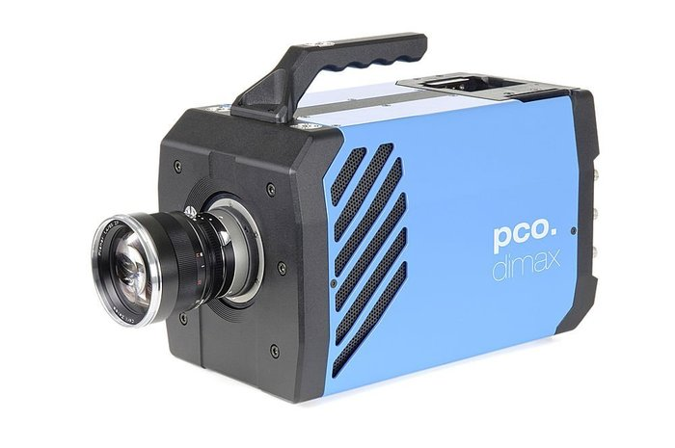
Fig. 1 Example of an unacceptable low-resolution image

1.5 Symbols and Abbreviations

Use only standard symbols in text and illustrations. Unusual units and abbreviations should be defined the first time they are used.

1.6 Equations

The numbers identifying equations should be placed in parentheses on the right. Please, make sure that no ambiguities arise as follow

(1)

1.7 Sections

The manuscript should be divided into sections, subsections and sub-subsections with clearly marked subtitles (in accordance to instructions in section 1.2 above) and numbered numerically (e.g. 2.1.3). Type the main body of the text single-spaced, beginning flush left. Leave one blank line between paragraphs and between paragraphs and headings/sub-headings.

1.8 Fonts

If possible, the font Times New Roman, 12 pt, or similar looking fonts should be used.

1.9 Page Numbers

Do not apply page numbering.

2. MISSION OBJECTIVES

List and describe no more than 5 mission objectives and prioritize them. These should be quantitative in nature and serve as overall measures of effectiveness for the mission.

3. EXPERIMENTAL CONCEPT AND SETUP

Describe the overall concept and setup for your experiment. Description of the expected deliverables (e.g. returned samples, data amount, data rate, others). What outcome will you expect in the end?

4. KEY PERFORMANCE PARAMETERS

List and explain the technical rationale for 3-5 key performance parameters that enable the successful conduct of your mission idea.

5. SPACE SEGMENT DESCRIPTION

Describe the conceptual design for your mission system(s) for the space segment. Brief description of the type of hardware composing the experiment. List key specifications (e.g. mass, volume, peak and average power, link budget, etc.). Diagrams or simple CAD drawings are encouraged.

6. CONCEPT OF OPERATIONS

List and describe key mission elements for operations and describe their primary interfaces. Use diagrams and tables as appropriate. Describe the experiment process and your mission profile (mission duration, operations start, operations end, timeline). Describe the intended interaction from the ground. Describe specific operational needs (if any).

7. IMPLEMENTATION PLAN

Provide a reasonable estimate of total life cycle cost to include design, development, assembly, integration, testing, launch, operations and return (if necessary). List any facilities or other infrastructure to be used or needed. Describe the project organization. Present a top-level project schedule starting from authority to proceed. List and describe the top 5 project risks (technical or programmatic) and possible countermeasures.

8. REFERENCES

References to published literature should be quoted in the text in brackets and grouped at the end of the paper in numerical order, typed 10 pt and presented as follows:

[1] J. K. Knowles and E. Reissner, Note on stress-strain relations for thin, elastic shells. J. Math. Phys. 37, 269-282 (1958)
[2] H. S. Carslaw and J. C. Jaeger, Operational Methods in Applied Mathematics, 2nd edition. p.121. Oxford University Press, London (1953)
[3] Authors’ Guidelines. Available online at: www.dlr.de/iaa.symp (accessed August 2015)

