Instructions to authors for the preparation of final paper (max 12 pages)
The title of the paper is typed 16 pt, bold, the initial capitalized only and centered at the top of the page.

Your Name(s)
Your affiliation, address,
postal code, City, Country
Phone: +xx xxx xxxx xxx, Fax: +xx xxx xxxx xxx, your_email@xxx.org
The name of the author(s) is typed 12 pt bold centered in upper and lower case letters. Affiliation(s) and complete address(es) are typed 12 pt centered in upper and lower case letters.

===Explanation of template starts from here. ===
This is a template of full paper for the 5th Mission Idea Contest for Micro/Nano-satellite Utilization.

Please submit your manuscript as a WORD file (.docx) through MIC application website where you submitted the abstract (http://www.spacemic.net/application5.html), and send a PDF file by email to MIC office (info@spacemic.net). Note that only submissions in the English language will be accepted.

The paper should not exceed 12 pages in total length and should strictly adhere to the following outline and formatting guidelines.

Please feel free to contact Contest Secretariat for any questions at info@spacemic.net.

==Explanation ends. Please delete unnecessary parts when you write. ==

Abstract: A one paragraph abstract, of not more than 300 words, must be included at the beginning of the paper. It should be a summary (not an introduction) and complete in itself. The abstract should indicate the subject dealt with in the paper and should state the overview of your mission idea. Readers should not have to read the whole paper to understand the abstract.

1. INTRODUCTION

In this section, describe the fundamental need (humanitarian, business, scientific, etc.) your mission idea addresses. For example, "Equatorial countries need timely tsunami warnings," and why this need is not being fully addressed by current or conventional large space systems.

1.1 Paper Title

The title of the paper is typed 16 pt, bold, the initial capitalized only and centered at the top of the page. The name of the author(s) is typed 12 pt bold centered in upper and lower-case letters. Affiliation(s) and complete address(es) are typed 12 pt centered in upper and lower-case letters.

1.2 Headings

Headings of the sections are typed 12 pt in capital letters, placed flush left. Subheadings and sub-subheadings are typed 12 pt in bold upper and lower-case letters placed flush left.

1.3 Footnotes

Footnotes should appear only, if it is necessary. Footnotes are typed 10 pt.

1.4 Illustrations and Captions

Keep in mind, please, that all figures and graphs will be reproduced exactly as you submit them. Therefore, make sure to provide them in an adequate quality. Place captions, numbered in their respective order, beneath the figures and above the tables, as shown in Table 1 and Fig. 1.
Table 1 Font sizes for papers
Font Size | Appearance (in Time New Roman or similar looking fonts)
 | Regular | Bold | Italic
16 |  | title
12 | author email, address and affiliation | Author name(s)  Headings (in capital letters),  Subheadings and  Sub-subheadings (in upper and lower case letters)
11 | cell in a table | table caption,  figure caption
10 | reference item  abstract body | abstract heading | reference item (partial)

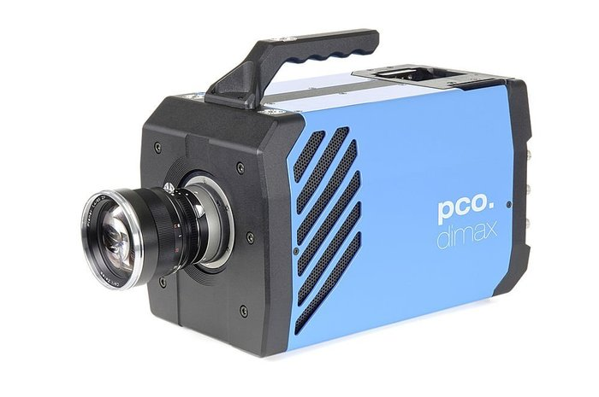
Fig. 1 Example of an unacceptable low-resolution image

1.5 Symbols and Abbreviations

Use only standard symbols in text and illustrations. Unusual units and abbreviations should be defined the first time they are used.

1.6 Equations

The numbers identifying equations should be placed in parentheses on the right. Please, make sure that no ambiguities arise as follow

(1)

1.7 Sections

The manuscript should be divided into sections, subsections and sub-subsections with clearly marked subtitles (in accordance to instructions in section 1.2 above) and numbered numerically (e.g. 2.1.3). Type the main body of the text single-spaced, beginning flush left. Leave one blank line between paragraphs and between paragraphs and headings/sub-headings.

1.8 Fonts

If possible, the font Times New Roman, 12 pt, or similar looking fonts should be used.

1.9 Page Numbers

Do not apply page numbering.

2. MISSION OBJECTIVES

List and describe no more than 5 mission objectives and prioritize them. These should be quantitative in nature and serve as overall measures of effectiveness for the mission.

3. CONCEPT OF OPERATIONS

List and describe key mission elements (ground segments, space segments, launch, etc.) and describe their primary interfaces. Use diagrams and tables as appropriate.

4. KEY PERFORMANCE PARAMETERS

List and explain the technical rationale for 3-5 key performance parameters that enable the successful conduct of your mission idea. For example, tsunami detection may depend on better than 20 m spatial resolution in the visible spectrum.

5. SPACE SEGMENT DESCRIPTION

Describe the conceptual design for your satellite system or systems. List key specifications (e.g. mass, volume, peak and average power, link budget, delta-V, etc.). Diagrams or simple CAD drawings are encouraged.

6. ORBIT/CONSTELLATION DESCRIPTION

Describe the orbital elements for the desired mission and explain the technical rationale for its selection. Presentation of analytical results ground coverage or user access computations or simulations is encouraged.

7. IMPLEMENTATION PLAN

Describe how your organization, or your organization working with others, could implement your idea. Provide a reasonable estimate of total life cycle cost to include design, development, assembly, integration, testing, launch, operations and disposal. Provide considerations about project sustainability. List any facilities or other infrastructure to be used or needed. Describe the project organization. Present a top-level project schedule starting from authority to proceed. List and describe the top 5 project risks (technical or programmatic).

8. REFERENCES

References to published literature should be quoted in the text in brackets and grouped at the end of the paper in numerical order, typed 10 pt and presented as follows:

[1] J. K. Knowles and E. Reissner, Note on stress-strain relations for thin, elastic shells. J. Math. Phys. 37, 269-282 (1958)
[2] H. S. Carslaw and J. C. Jaeger, Operational Methods in Applied Mathematics, 2nd edition. p.121. Oxford University Press, London (1953)
[3] Authors’ Guidelines. Available online at: www.dlr.de/iaa.symp (accessed August 2015)

